Media Contact:  Frank Doris/Public Relations  631-645-5668  frankdoris@frankdoris.com | Company Contact:  Brett Smalley  778-284-6942 Ext. 117  brett.smalley@kantoliving.com

NEWS RELEASE
FOR IMMEDIATE RELEASE

Kanto Exhibits Its TUK High-End Powered Speaker
With AMT Tweeter, Bluetooth® 4.0, Phono Connectivity
and More at CES 2019

-- TUK is Kanto’s new premium top of the line powered speaker system --

COQUITLAM, BC, CANADA, JANUARY 8, 2019 – At CES 2019, Kanto is exhibiting its new TUK high-performance powered stereo speaker system with wireless capability. TUK is the most advanced speaker system ever offered by Kanto and combines exceptional sound with flexible connection options and remote-control operation. It will begin shipping in the first quarter of 2019.

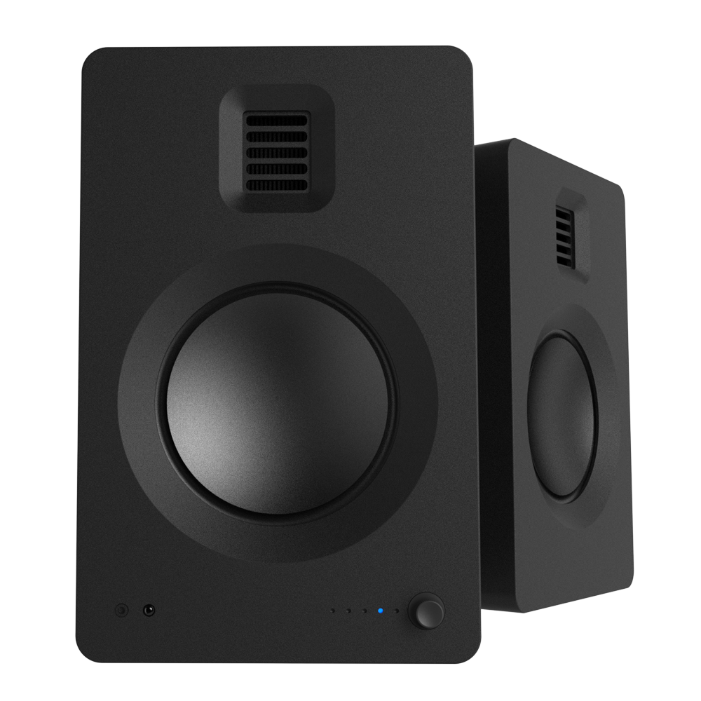
TUK is on exhibit at CES 2019 in Las Vegas, NV at The Venetian, Suite 29-118 (January 8 – 11, 2019).

Designed for true high-end powered speaker performance, TUK provides high-quality wireless Bluetooth music streaming with Qualcomm® aptX™ HD and AAC, plus analog and digital audio inputs. In addition, TUK has a phono preamp and phono input to use with a turntable. TUK is especially suited for nearfield and desktop listening, with features including a built-in headphone amp and a USB DAC.

“We created TUK as an easy to use, compact speaker system that lets listeners step up to high-quality sound on a level that is usually heard from audio separates,” said Brett Smalley, Kanto Marketing Manager.

TUK features a newly-designed 28 x 35 mm Air Motion Transformer (AMT) tweeter, which employs a pleated low-mass diaphragm that pushes back and forth on itself to move air. This configuration delivers superlative high-frequency resolution, clarity and transient response.

The AMT tweeter is complemented by an aluminum concave-cone woofer
and a powerful 65 watt-per-channel stereo amplifier. The amplifier is designed to perfectly match the drivers for a smooth tonal balance.

In addition to Bluetooth capability, TUK includes analog line inputs, an optical digital input, a USB DAC input and an RCA phono input. TUK provides a 3.5 mm headphone output, a subwoofer output with selectable high-pass filter and a handy USB charging output.

TUK has an elegant, minimalist design and is available in matte black and matte white to complement any living or office space. It comes with a remote control, magnetic detachable fabric grille, speaker wire, power cord, 3.5 mm to RCA cable and a USB DAC cable.

Kanto’s TUK will be available in the first quarter of 2019 at MAP pricing of $799 US, $999 Canadian.

Click here for TUK high-resolution images.

# # #

ABOUT KANTO (kantoaudio.com)

Operating out of Metro Vancouver, BC, Kanto has been designing and manufacturing audio products since 2007. Their mission to provide an auditory experience to excite the senses has led to the development of a full line of speakers and audio accessories. For laid-back listeners, hardcore gamers and vinyl enthusiasts alike, Kanto speakers leave no one behind. For more information, visit http://www.kantoaudio.com or email marketing@kantoliving.com.

The Bluetooth® word mark and logos are registered trademarks owned by the Bluetooth
SIG, Inc. and any use of such marks by Kanto is under license. Other trademarks and trade names are those of their respective owners.

Qualcomm aptX is a product of Qualcomm Technologies International, Ltd.

Qualcomm is a trademark of Qualcomm Incorporated, registered in the United States and other countries, used with permission. aptX is a trademark of Qualcomm Technologies International, Ltd., registered in the United States and other countries, used with permission.

