
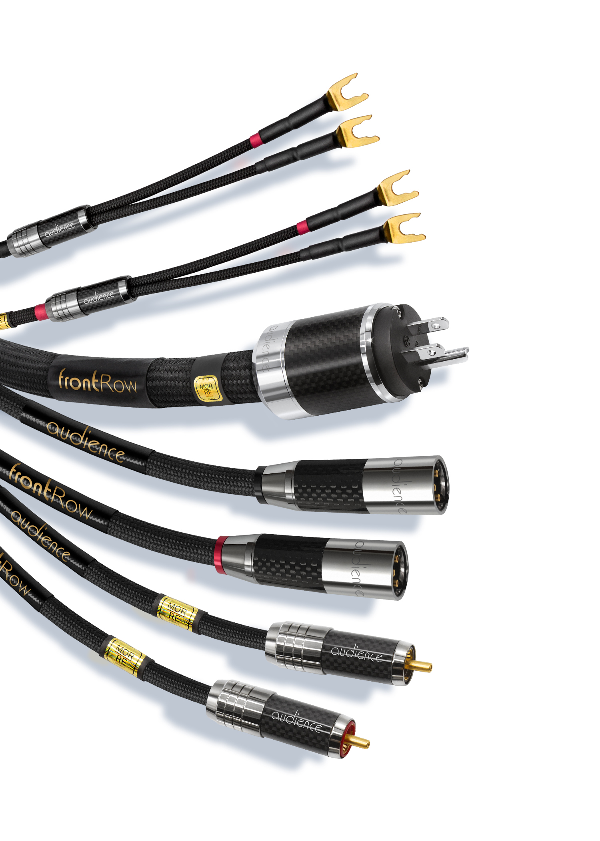
NEWS RELEASE

Media Contact:
Frank Doris / Public Relations
631-645-5668
frankdoris@frankdoris.com

Audience
800-565-4390 (US and Canada)
info@audience-av.com

Audience Sets a New Standard in Audio Cable Performance with Debut of Its frontRow Interconnects, Loudspeaker and Power Cables

San Marcos, CA, January 30, 2019 – Audience today announced it is now shipping its new top of the line frontRow audio cables, a complete range of balanced and unbalanced interconnect, phono, digital, speaker and power cables that incorporate the company’s newest MORRE (Musically Optimized Reduction of Resistive Energies) technologies to deliver extraordinary new levels of musical accuracy.

“Our new frontRow cables build upon the performance of our previous award-winning Au24 SX models and are a major advance in what we thought was sonically possible,” said John McDonald, president of Audience.

Audience’s MORRE technologies are the result of more than 22 years of experience in cable design. Every aspect of frontRow cables has been considered and refined, including cable geometries, metallurgy, connectors, shielding, dielectric and jacketing materials and the interaction between conductors – even details like the mechanical resonant frequencies of the materials used.

MORRE provides a dramatic lowering of the noise floor and distortion artifacts. The sonic result is improved low-level resolution and wider dynamic contrasts, and a remarkably lifelike musical presentation with more realistic “3-D” imaging and soundstaging.

To ensure maximum signal integrity, frontRow cables utilize conductive material made from modified 99.9999% Ohno Continuous Cast (OCC) copper, 99.9999% pure silver or high-purity silver-plated copper using the optimum material for each frontRow cable model. The cables use XLPE (cross-linked polyethylene) dielectric material, chosen for its superior insulating properties and low microphonics, as well as Teflon and other materials. Depending on the model and application, MORRE can use twinaxial, coaxial, proprietary Perfect Lay, Double Cylindrical, Double Helix or other custom-stranded multi-conductor wire geometries. All configurations are designed to maintain maximum signal purity and reduce noise.
Careful attention is paid to connector design and construction. Every point of contact between the connectors and the conductors has been optimized to avoid the introduction of noise, interference, signal loss and other unwanted effects, employing metals including tellurium and beryllium copper, rhodium, gold and silver. frontRow cables utilize either proprietary solderless connections or state-of-the-art soldering materials and techniques.

frontRow cables are treated with Audience’s EHVP Extreme High-Voltage Process, which applies high voltages in specific combinations. This proprietary technique aligns the crystalline structure of the various metals used in the cables to create more efficient “pathways” for signals to travel through the materials. To further maximize performance, the cables receive Audience’s Deep Cryo II treatment, which relieves stresses that are created in the drawing and manufacturing of the wire, strengthens the conductors and provides additional benefits.

Audience frontRow cables are meticulously manufactured to the highest standards. Every cable is tested and burned in for at least three days.

Audience frontRow cables and interconnects are currently available. A one-meter pair of frontRow cables with RCA terminations has a suggested retail price of $3,300 per pair. Please consult Audience or an authorized Audience dealer for pricing of other lengths and configurations.

Click here for a high-resolution image.

# # #

About Audience

Audience was formed in November 1997 by John McDonald and the late Richard Smith, as a design and production company focused on building the best possible audio and video equipment. To pass the Audience test, each product must truly make a significant contribution to the reproduction of audio and/or video. Audience offers loudspeakers, electronics, cables, power conditioners, high-resolution capacitors and the Auric Illuminator optical disk resolution enhancement.

Audience’s commitment is to develop the very best products possible, and the company is committed to unexcelled customer service and product support. All Audience cables have an unconditional lifetime warranty and power conditioners have a ten-year warranty. For more information visit www.audience-av.com.

